**ROJECT CLASS**

**MOROCCO**



**Energy Storage Solutions: Electromagnetism for Developing Efficient and Sustainable Battery Technologies**

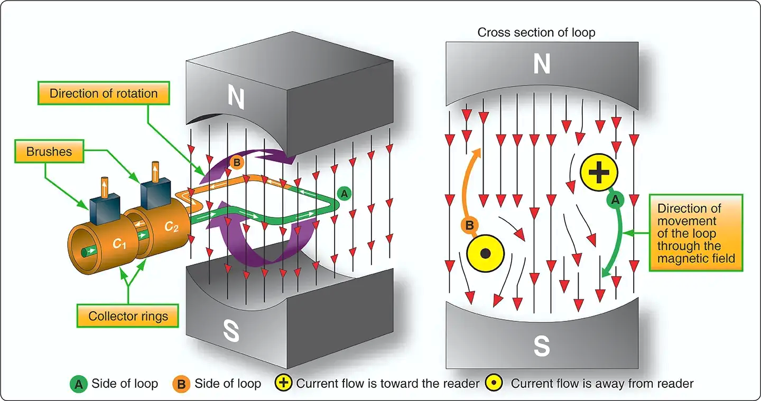

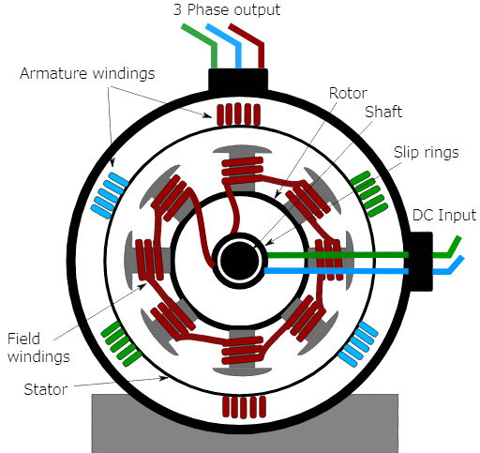

The researcher : **HASSAN IHYAOUI**

Supervised by : **Prof. Mohamed Fettah**

School: **Moulay Ismail High School**

**Abstract**

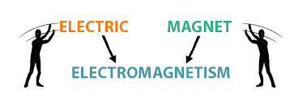

**Electromagnetism remains a cornerstone of modern technology, playing a pivotal role in various applications from telecommunications to power generation and transportation. This research underscores the critical importance of electromagnetism in today's technological landscape, emphasizing its indispensable role in advancing sustainable development goals.**

**Central to this study is the exploration of energy storage solutions, a pressing global challenge that demands innovative approaches for sustainable development. In particular, the focus is on the development of advanced battery technologies based on electromagnetism. These technologies not only promise enhanced energy storage capacities but also strive towards sustainability by reducing reliance on fossil fuels and minimizing environmental impact.**

**The research investigates how advancements in electromagnetism-based battery technologies can significantly contribute to sustainable development initiatives. By enabling more efficient energy storage and utilization, these technologies have the potential to revolutionize renewable energy integration, electric vehicle performance, and grid stability. Moreover, they pave the way for a cleaner and more resilient energy infrastructure capable of meeting future energy demands while mitigating climate change effects.**

**Through a comprehensive analysis of current trends, technological advancements and potential future applications, this research underscores the transformative impact of electromagnetism on achieving sustainable development goals. It advocates for continued research and innovation in this field as a pathway towards a more sustainable and energy-efficient future.**

**Ultimately, this research serves as a call to action, urging policymakers, educators, and individuals alike to engage in dialogue and enact policies that promote the use of clean and renewable energies.**

"Electricity and magnetism are those forces of nature by which people can explain everything"

Egon Friedell

**Outline**

1. **Part One...........................................................................**
2. **Introduction**
   1. Overview of electromagnetism's importance in modern technology.
   2. Significance of energy storage solutions for sustainable development.
3. **Fundamentals of Electromagnetism**
   1. Maxwell's equations and their implications for energy generation and storage.
   2. Application of electromagnetism in various industries.
4. **Importance of Energy Storage**
   1. Global energy demands and challenges posed by intermittent renewable sources.
   2. Role of energy storage in enabling renewable energy integration.
5. **Battery Technologies Based on Electromagnetism**
   1. Overview of current battery technologies (lithium-ion, lead-acid, etc.)
   2. Advantages and limitations of electromagnetism-based battery technologies.
6. **Innovative Approaches in Battery Research**
   1. Materials science advancements for improving energy density and efficiency.
   2. Computational modeling and simulation techniques for battery design optimization.
7. **Environmental and Sustainability Considerations**
   1. Environmental impact assessment of current battery technologies.
   2. Potential benefits of electromagnetism-based batteries for reducing carbon footprint.
8. **Part Two...........................................................................**
9. **A perpetual motion machine**
10. **Experimental Setup and Methodology**
    * Selection of experimental parameters (battery types, materials, etc.)
    * Description of testing apparatus and data collection methods.
11. **Analysis of Experimental Results**
    * Comparison with theoretical predictions and existing battery technologies.
    * Interpretation of data to validate hypotheses and draw conclusions.
12. **Discussion and Future Directions**
    * Implications of experimental findings for sustainable development goals.
    * Recommendations for further research and technological advancements.
13. **A video of my speech to the world.**

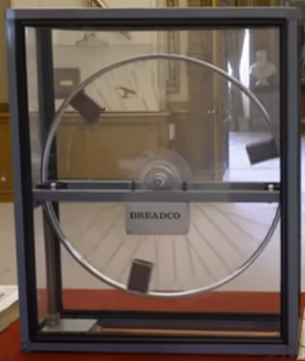

**Introduction:**

**Electricity and magnetism were long thought to be separate forces. It was not until the 19th century that they were finally treated as interrelated phenomena. In 1905 Albert Einstein’s special theory of relativity established beyond a doubt that both are aspects of one common phenomenon. Which is Electromagnetism. So, what is Electromagnetism?**

**In physics, it is an interaction that occurs between particles with electric charge via electromagnetic fields. The electromagnetic force is one of the four fundamental forces of nature. It is the dominant force in the interactions of atoms and molecules. Electromagnetism can be thought of as a combination of electrostatics and magnetism, which are distinct but closely intertwined phenomena.**

**At a practical level, however, electric and magnetic forces behave quite differently and are described by different equations. Electric forces are produced by electric charges either at rest or in motion. Magnetic forces, on the other hand, are produced only by moving charges and act solely on charges in motion. But how was this force discovered through history?**

**Ancient civilizations, including the Greeks and Mayans, explored lightning, static electricity, and magnetism. There is evidence that these civilizations knew that the naturally magnetic mineral magnetite had attractive properties, and many incorporated it into their art and architecture. They were also aware of lightning and static electricity, although they had no idea of the mechanisms behind these phenomena. Despite all this investigation, ancient civilizations had no understanding of the mathematical basis of electromagnetism, and often analyzed its impacts through the lens of religion rather than science (lightning, for instance, was considered to be a creation of the gods in many cultures).**

**In the 18th and 19th centuries, scientists like Coulomb, Gauss, and Faraday developed laws to explain electromagnetic phenomena. Electricity and magnetism were originally considered to be two separate forces. This view changed with the publication of James Clerk Maxwell's 1873 "A Treatise on Electricity and Magnetism" in which the interactions of positive and negative charges were shown to be mediated by one force.**

**In 1802, Gian Domenico Romagnosi, an Italian legal scholar, deflected a magnetic needle using a Voltaic pile. The factual setup of the experiment is not completely clear, nor if current flowed across the needle or not. An account of the discovery was published in 1802 in an Italian newspaper, but it was largely overlooked by the contemporary scientific community, because Romagnosi seemingly did not belong to this community.**

**In April 1820, Hans Christian Oersted observed that an electrical current in a wire caused a nearby compass needle to move. At the time of discovery, Oersted did not suggest any satisfactory explanation of the phenomenon, nor did he try to represent the phenomenon in a mathematical framework. However, three months later he began more intensive investigations. Soon thereafter he published his findings, proving that an electric current produces a magnetic field as it flows through a wire. His findings resulted in intensive research throughout the scientific community in electrodynamics. They influenced French physicist André-Marie Ampère's developments of a single mathematical form to represent the magnetic forces between current-carrying conductors. Oersted's discovery also represented a major step toward a unified concept of energy.**

**This unification, which was observed by Michael Faraday, extended by James Clerk Maxwell, and partially reformulated by Oliver Heaviside and Heinrich Hertz, is one of the key accomplishments of 19th-century mathematical physics. It has had far-reaching consequences, one of which was the understanding of the nature of light.**

**Maxwell’s equations in the 1860s provided a complete mathematical description of classical electromagnetic fields. Maxwell’s equations describe how electric and magnetic fields interact:**

* + - **The electric field converges toward or diverges away from electric charges.**
    - **The magnetic field curls around electrical currents.**
    - **Changes in one field influence the other.**

**Clearly, electric Forces cause attraction between particles with opposite charges and repulsion between particles with the same charge. This interaction between these particles is called Magnetism; and this last arises from the interaction between charged particles in relative motion.**

**In other words, an electromagnetic field represents the influences on and due to electric charges. It combines both an electric field and a magnetic field at any point in space and time. When charges or currents interact with this field, it leads to phenomena like electromagnetic waves. These waves propagate through space at the speed of light. Depending on their frequency, they span different regions of the electromagnetic spectrum. An electromagnetic wave has two components:**

* + - **Electric Field: Oscillates along one direction.**
    - **Magnetic Field: Oscillates perpendicular to the electric field.**

**Together, they form a transverse wave that carries energy. The electromagnetic force is the second strongest of the four known fundamental forces. It operates with infinite range. It is the invisible force that shapes our modern world which has been related to Technology.**

**Electromagnetism significantly impacts technology in various ways. Here are some key points:**

* **Electricity Generation and Distribution:**
  + - **Electromagnetic generators (such as turbines) convert mechanical energy into electrical energy. Power plants use this principle to generate electricity.**
    - **Transformers rely on electromagnetic induction to step up or step-down voltage for efficient power distribution.**
* **Chemistry:** 
  + - **The electrostatic attraction between atomic nuclei and electrons holds atoms together. It allows atoms to combine into molecules.**
    - **Magnetic interactions influence chemical reactivity.**
* **Electronics and Communication:**
  + - **Circuits: Electronic devices (computers, smartphones, TVs) operate based on electromagnetic principles. Circuits use conductors, resistors, capacitors, and inductors.**
    - **Radio Waves: Electromagnetic waves (radio, microwaves) enable wireless communication, including Wi-Fi, cellular networks, and satellite communication.**
* **Magnetic Storage:**
  + - **Hard drives and magnetic tapes store data using tiny magnetic domains. Read/write heads manipulate these domains based on electromagnetic principles.**
* **Motors and Actuators:**
  + - **Electric motors (used in appliances, vehicles, industrial machinery) convert electrical energy into mechanical motion through electromagnetic interactions.**
    - **Solenoids and relays are also essential electromechanical devices.**
* **Medical Imaging:**
  + - **MRI (Magnetic Resonance Imaging) machines use strong magnetic fields and radio waves to create detailed images of internal body structures.**
* **Electromagnetic Compatibility (EMC):**
  + - **Engineers design devices to minimize electromagnetic interference (EMI) and ensure compatibility between different technologies.**

**The Scotsman James Clerk Maxwell (1831–1879) is regarded as the greatest theoretical physicist of the 19th century. Although he died young, Maxwell not only formulated a complete electromagnetic theory, represented by Maxwell's equations, he also developed the kinetic theory of gases and made significant contributions to the understanding of color vision and the nature of Saturn’s rings.**

**Maxwell brought together all the work that had been done by brilliant physicists such as Oersted, Coulomb, Gauss, and Faraday, and added his own insights to develop the overarching theory of electromagnetism. Maxwell’s equations are paraphrased here in words because their mathematical statement is beyond the level of this text. However, the equations illustrate how apparently simple mathematical statements can elegantly unite and express a multitude of concepts—why mathematics is the language of science.**

**Maxwell’s equations, four equations that, together, form a complete description of the production and interrelation of electric and magnetic fields. The physicist James Clerk Maxwell, in the 19th century, based his description of electromagnetic fields on these four equations, which express experimental laws.**

**These equations are, respectively, the following:**

**1. Gauss’s Law for Electricity (Integral Form):**

**∮E⋅dA=ε0​Qenc​​**

* **This equation relates the electric field within a closed surface.**

**2. Gauss’s Law for Magnetism (Integral Form):**

**∮B⋅dA=0**

* **The magnetic field has no isolated magnetic charges (monopoles), so the net magnetic flux through any closed surface is zero.**

**3. Faraday’s Law of Electromagnetic Induction (Integral Form):**

**∮E⋅ds=−dtdΦB​​**

* **Changing magnetic flux induces an electric field along a closed loop.**

**4. Ampère-Maxwell Law (Integral Form):**

**∮B⋅ds=μ0​(Ienc​+ε0​dtdΦE​​)**

* **This equation combines Ampère’s law with a new term—the displacement current—accounting for changing electric fields.**

**Displacement Current and Electromagnetic Waves Maxwell introduced the displacement current term to Ampère’s law, addressing its limitations. When a time-varying electric field exists between the plates of a capacitor, a displacement current flows even in the absence of actual charge movement. This correction ensures that Ampère’s law remains valid for all situations, including non-steady currents.**

**Now, the symmetry between changing electric and magnetic fields leads to an exciting prediction: the existence of electromagnetic waves. Maxwell realized that these waves would propagate through space, carrying energy. He correctly anticipated that visible light itself consists of such electromagnetic waves.**

**Hertz’s Confirmation Heinrich Hertz experimentally confirmed Maxwell’s prediction by generating and detecting electromagnetic waves. His experiments demonstrated the existence of radio waves, which are a form of electromagnetic radiation.**

**With that knowledge, Maxwell changed the world forever. In the span of 150 years since his celebrated paper, numerous scientific discoveries and technological innovations have originated from Maxwell's equations. Electromagnetic and optical waves can be manipulated, tailored, and controlled by means of materials, and consequently, during the past one and a half centuries, materials science and engineering has always played the key roles in taming these waves for the purpose of inventing new functional devices. Early examples include radio-frequency antennas, lenses and mirrors, microwave waveguides, optical fibers, and telegraph transmission lines, to name just a few. Recent developments in nano-science and nanotechnology, materials science and technology, and condensed matter physics has made it possible to conceive materials and structures with atomic-level controllability and with unprecedented properties not otherwise present in naturally available materials. These developments have opened doors to numerous opportunities to shape and sculpt light at the nano-, micro- and meso-scales in a desired fashion. Therefore, electromagnetism plays a crucial role in various industries in our modern life. Let's explore some of its applications:**

* **Industrial Applications: Electric motors, solenoids, and magnetic sensors.**
* **Communication Systems: Radio waves, microwaves, and optical fibers.**
* **Medical and Scientific Equipment: MRI machines, NMR spectrometers, and particle accelerators.**
* **Consumer Electronics: Generators, motors, transformers, and data storage devices.**

**As a conclusion, electromagnetism is fundamental to our daily lives, powering everything from transportation to medical diagnostics such as Emission Reduction which helps mitigate climate change. Also Nil Fuel Costs which saves costs compared to fossil fuels. Likewise, Reduction of Carbon Emissions.**

**Therefore, the world is rapidly adopting renewable energy alternatives at a remarkable rate to address the ever-increasing environmental crisis of CO2 emissions. Renewable Energy System offers enormous potential to decarbonize the environment because they produce no greenhouse gases or other polluting emissions. However, the RES relies on natural resources for energy generation, such as sunlight, wind, water, geothermal, which are generally unpredictable and reliant on weather, season, and year. To account for these intermittencies, renewable energy can be stored using various techniques and then used in a consistent and controlled manner as needed. Several researchers from around the world have made substantial contributions over the last century to developing novel methods of energy storage that are efficient enough to meet increasing energy demand and technological breakthroughs.**

**Energy storage is a potential substitute for, or complement to, almost every aspect of a power system, including generation, transmission, and demand flexibility. Storage should be co-optimized with clean generation, transmission systems, and strategies to reward consumers for making their electricity use more flexible.**

**The intermittency of wind and solar generation and the goal of decarbonizing other sectors through electrification increase the benefit of adopting pricing and load management options that reward all consumers for shifting electricity uses with some flexibility away from periods when the balance between supply and demand is tight to periods of abundance. Advanced metering and behind the meter communications technologies make it feasible for state regulators to implement such strategies for residential and small commercial consumers.**

**There are several types of energy storage solutions, each with unique advantages and applications. Here are some of the most prominent ones:**

* **Battery Storage:**
* **Lithium-ion Batteries: High energy density, used in electric vehicles and grid storage.**
* **Flow Batteries: Use liquid electrolytes, suitable for large-scale storage.**
* **Thermal Energy Storage:**
* **Molten Salt: Stores energy at high temperatures, used in solar power plants.**
* **Ice Storage: Stores energy as ice, used for cooling buildings.**
* **Mechanical Storage:**
* **Pumped Hydro: Pumps water to a higher elevation for later use.**
* **Flywheels: Store energy in a rotating mass for quick power bursts.**
* **Compressed Air Energy Storage (CAES): Compresses air in caverns or tanks, released to generate electricity.**
* **Hydrogen Storage: Converts electricity into hydrogen, stored for later use as fuel or electricity.**

**These technologies help balance supply and demand, enhance grid stability, and support the integration of renewable energy sources. Energy storage solutions are crucial for sustainable development for several reasons:**

* **Stability and Reliability: Ensures consistent energy supply even when natural conditions are unfavorable.**
* **Flexibility: Integrates renewable energy into the grid, reducing fossil fuel reliance.**
* **Environmental Benefits: Reduces greenhouse gas emissions and reliance on fossil fuels.**
* **Cost Efficiency: Lowers electricity costs by storing cheap energy and releasing it when expensive.**
* **Support for Remote Areas: Provides reliable power to regions with limited grid access.**
* **Economic Growth: Creates jobs and stimulates economic growth through investment in storage technologies.**